
Highlights from

St. John’s Military School

Salina, Kansas

(Forty-First Year)

1887

Circular of Information

1927-1928

(Received from Sheri Becker)

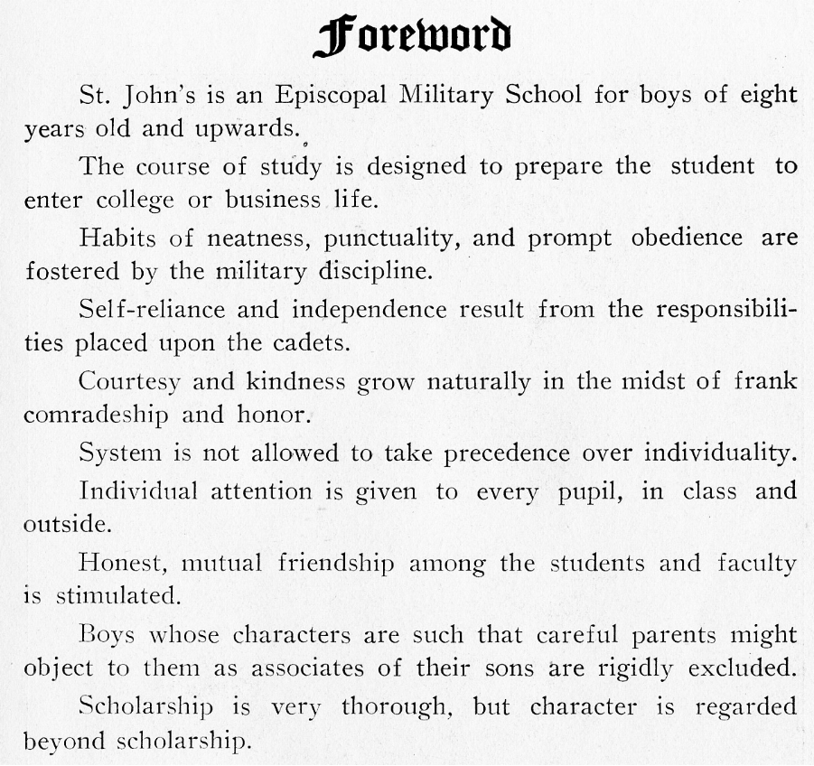
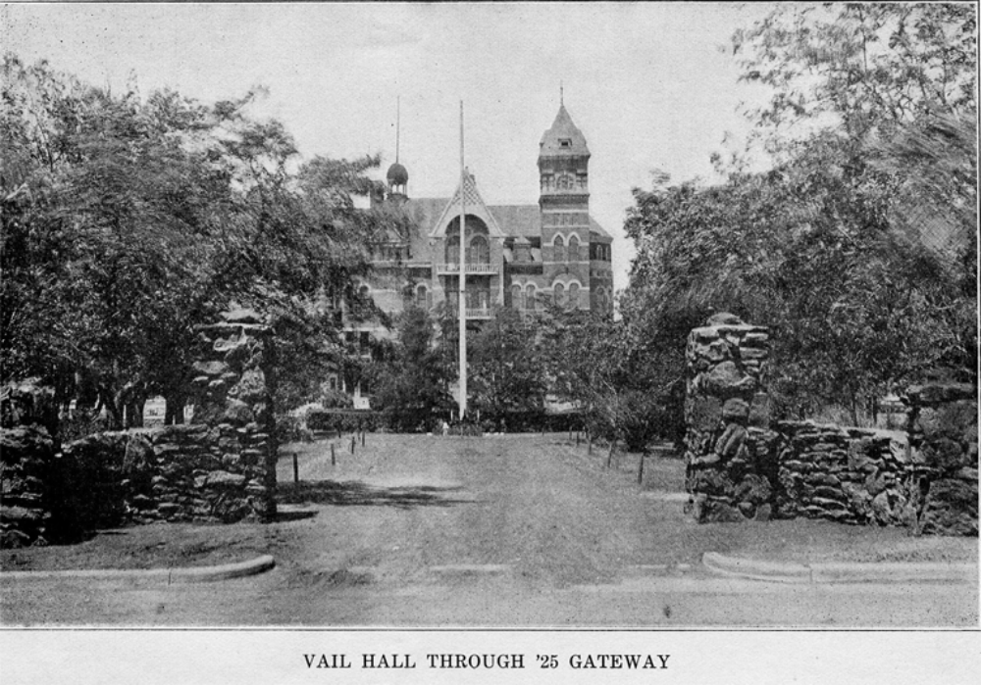
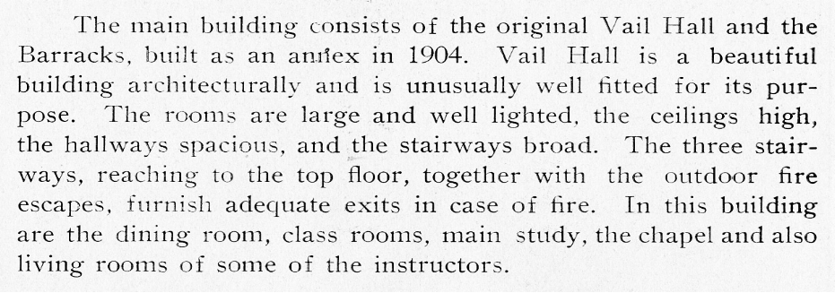

FACULTY

The faculty had a priest (D.D.) for Sacred Study, a superintendent (LL.B.) for Commercial Law & Economics, a Commandant for Military, a Headmaster (A.B.) for Latin and Spanish, an athletic director (B.S.) for Science, a bursar for Bookkeeping, a coach (unfilled) for Mathematics, a captain (B.S.) for English, a captain (unfilled) for History, a captain (A.B., B.S.) for Junior School, a captain for Junior School, a medical doctor (B.S., M.D.) for Physician, a medical doctor (A.B., M.D.) for Physician, a Housemother, coaches for Voice, Piano, Saxophone & Clarinet, and Violin.

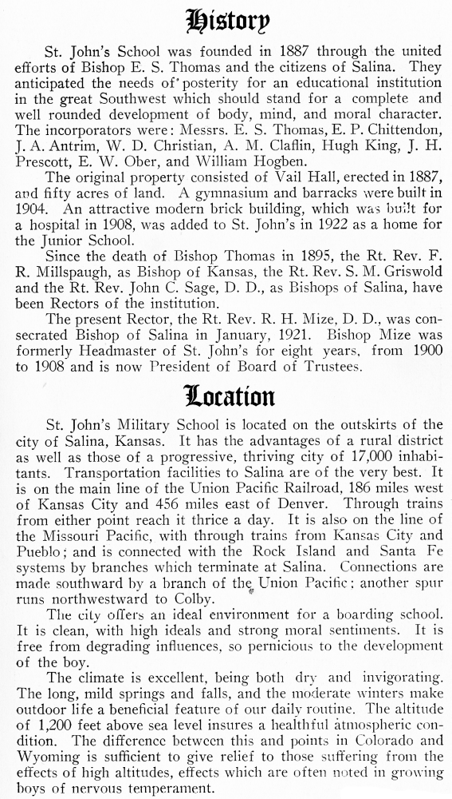
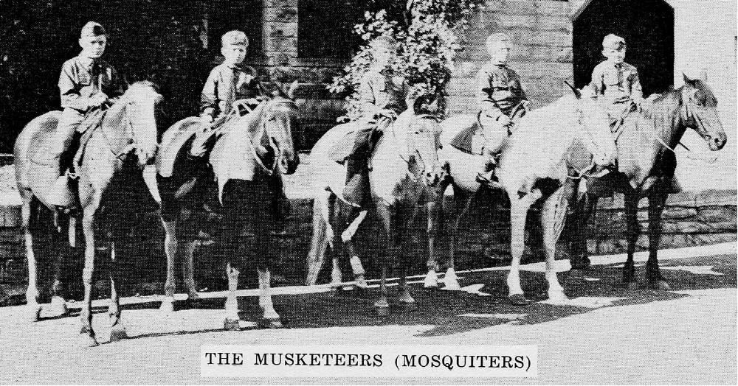

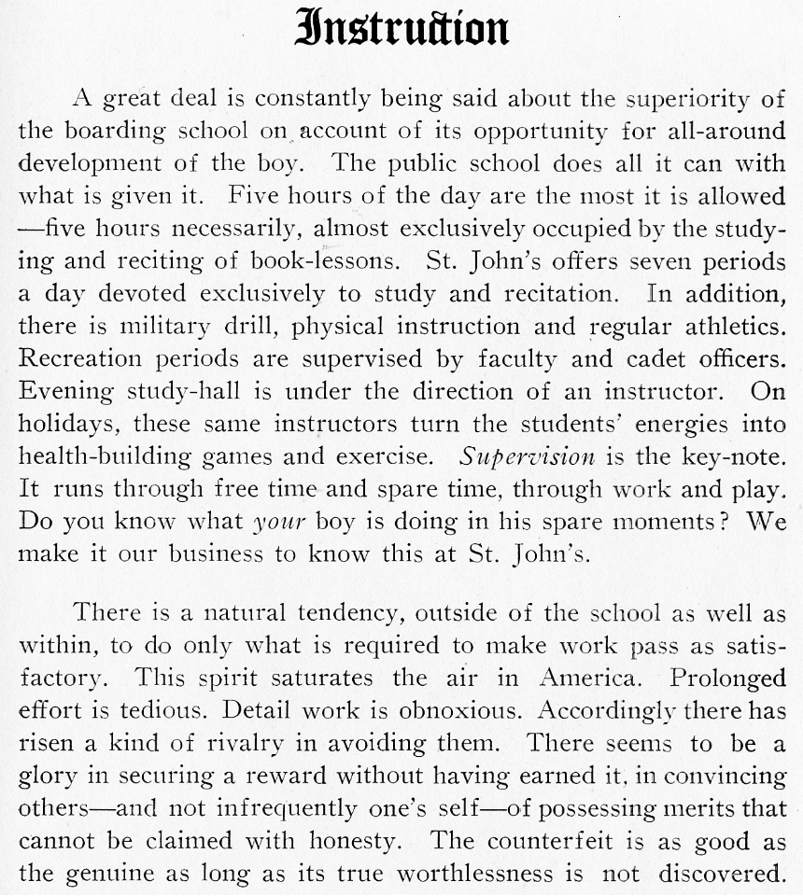
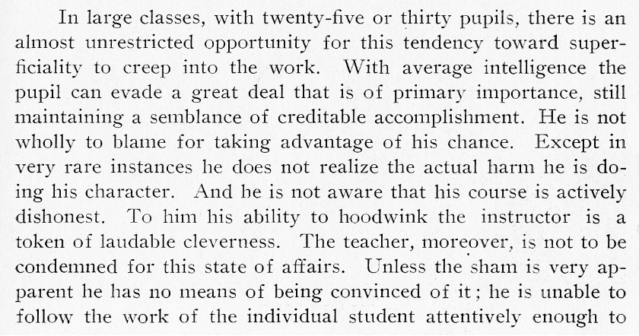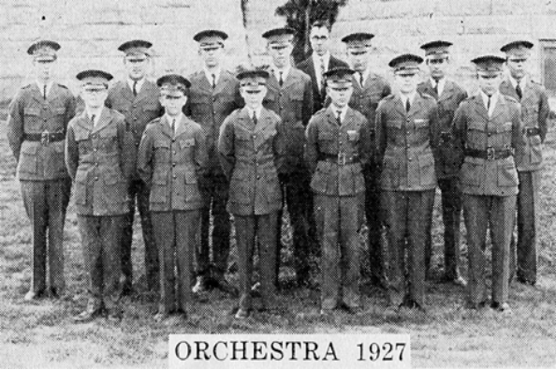
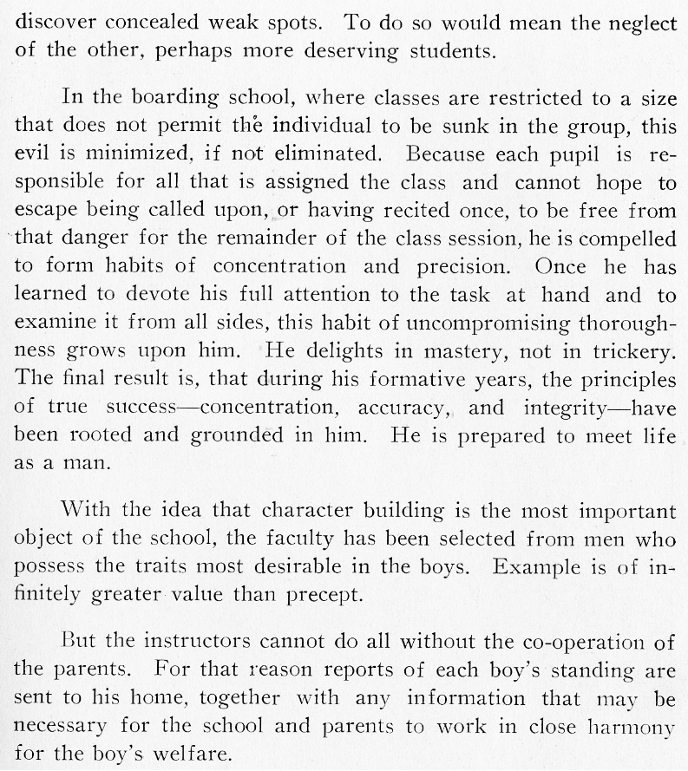
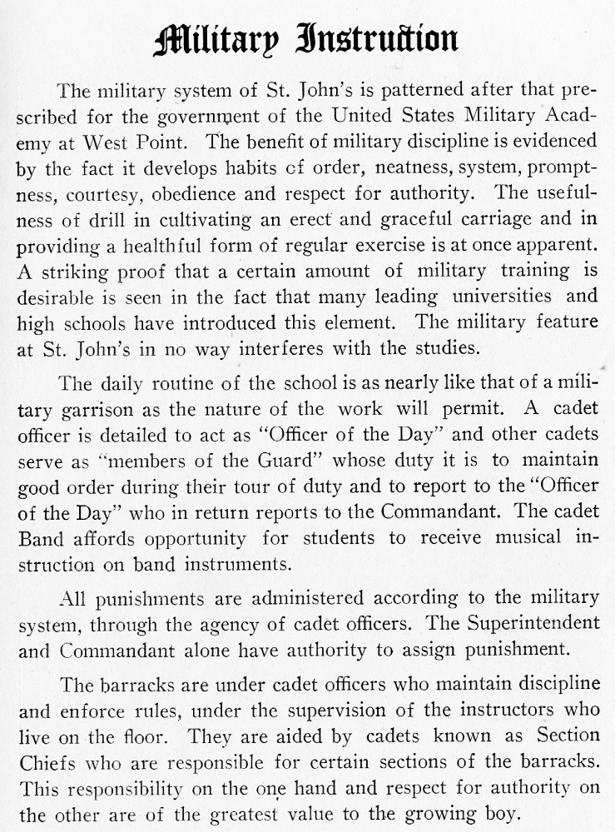

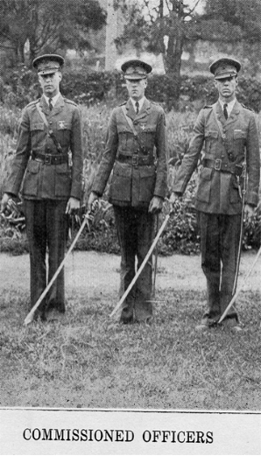
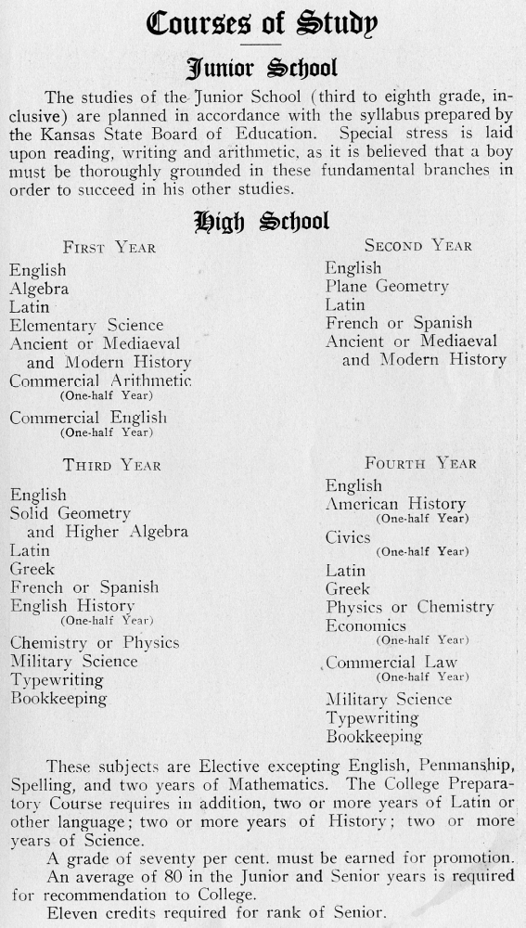

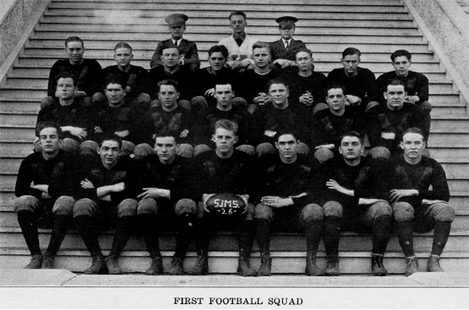

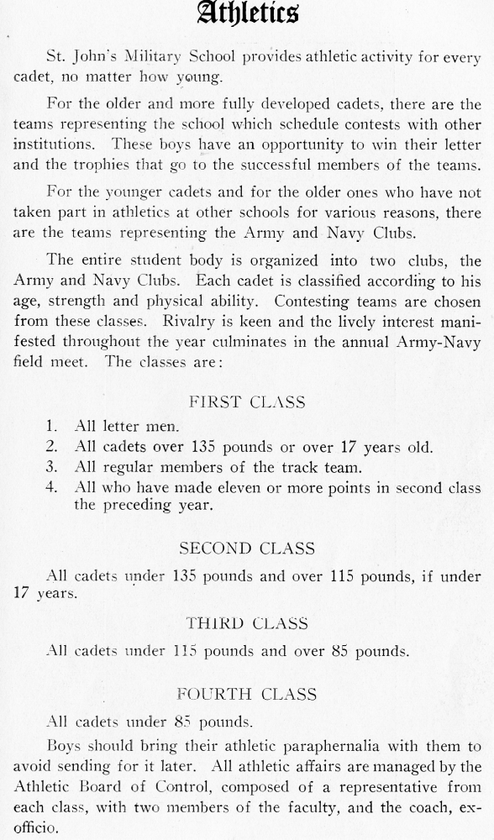
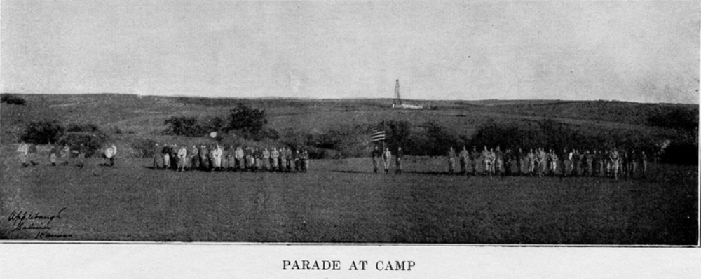

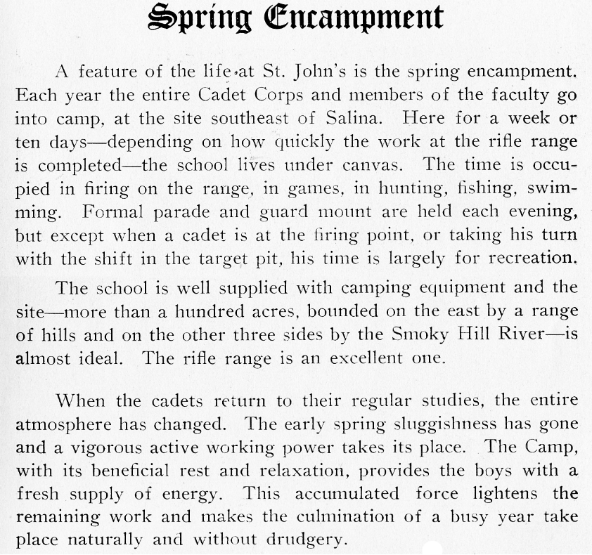

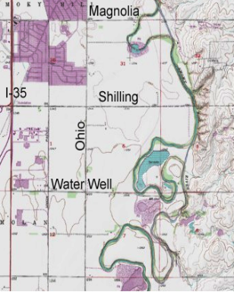
Where was this encampment location?

There are several “goose-neck” loops in the Smoky Hill formed by meanders in the flat land just southeast of Salina that fit the description given above. There are hills on the east side of the river that force its path to the north at this location.

The 100 acres referred to would form a square almost 0.4 mi. on a side. The distance between Shilling and Water Well roads is 1.0 mi. so the loop near the center of the picture is about the right size.


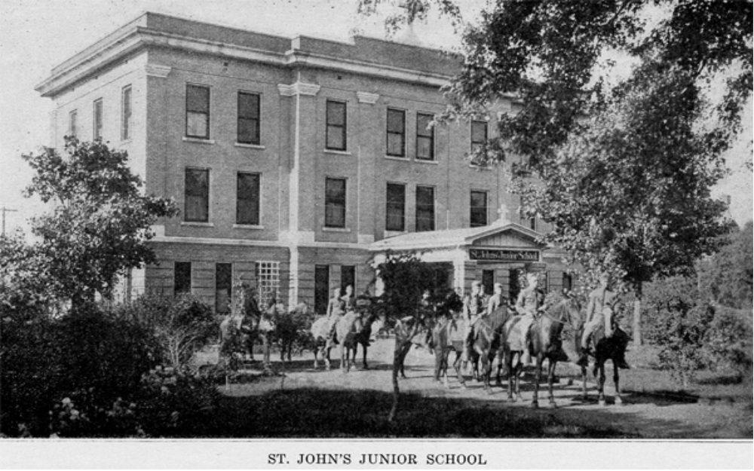

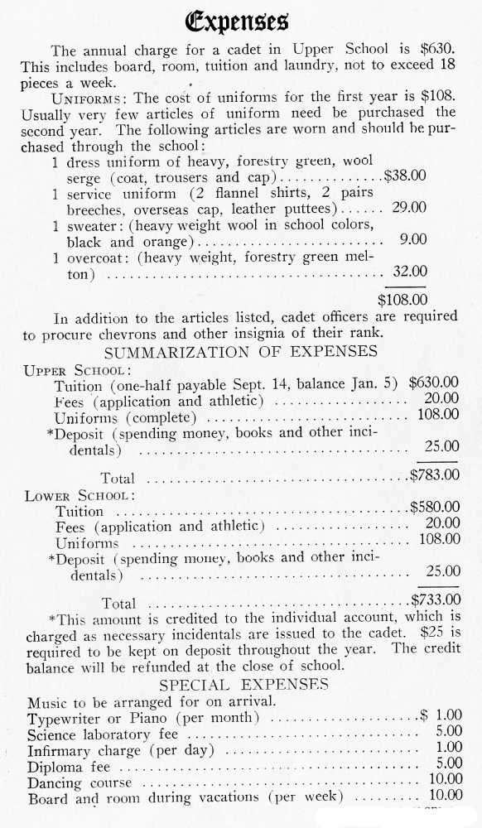

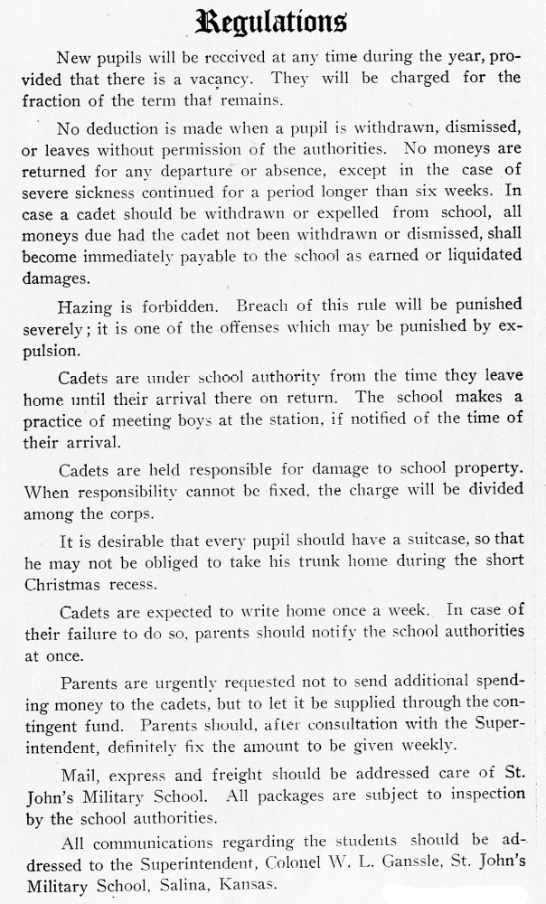

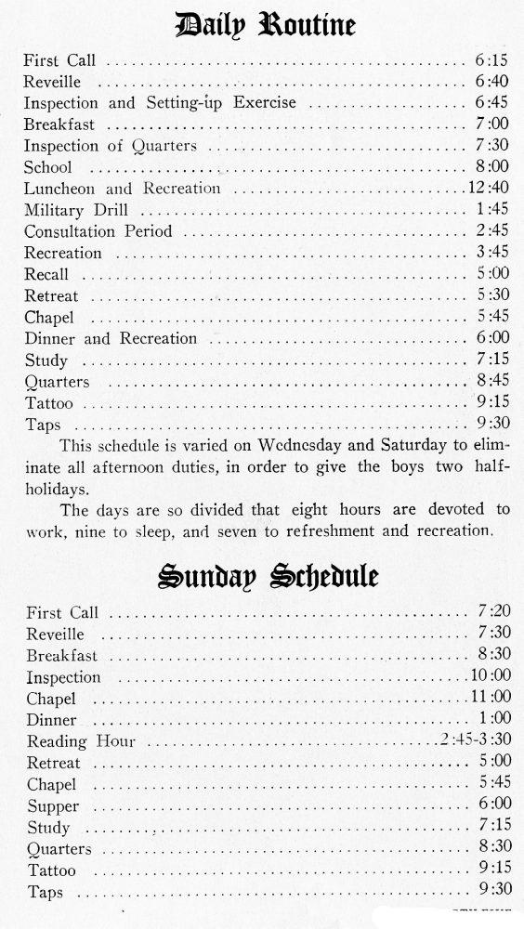

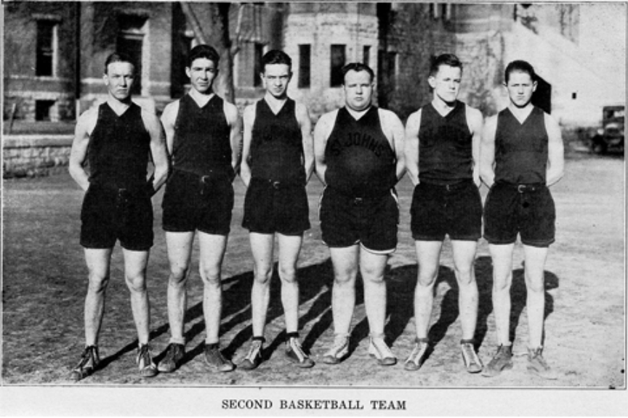

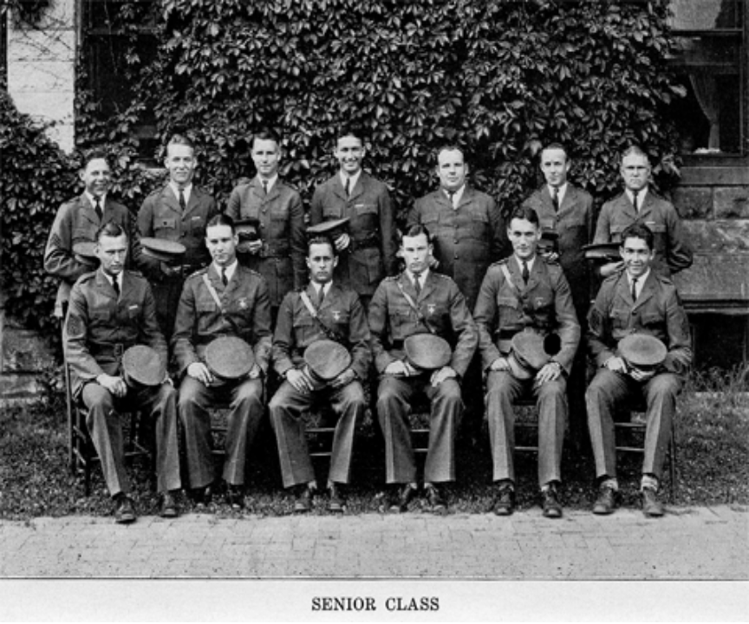

While informative and enjoyable to read, remember that this is 1927-1928 information and its relevance to today’s St. John’s Military School should not be immediately assumed. What is presented here is not even the entire Circular of Information but only highlights that seemed of interest today. Their latest web site (February, 2017) seems to be found at http://sjms.org/ .

