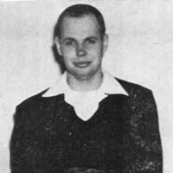
Don Larson, 1924-2017

1954 photo

Don Larson died Nov. 22, 2017 at the age of 93. He taught math while we were in Junior High starting in 1951. (This photo is from 1954 when we were in 9th grade.) Eight years later he began teaching math at "South Junior High" before shifting to South High School in 1970. He retired in 1985 and with wife Hildy moved to Arizona.

Comments from a niece of his, related to Phil Rinard through marriages.
2012. Don was in Salina his entire teaching career. They retired to Leisure World Arizona, probably because Don's sister had previously moved there. (In fact, the sister lived right next door to my wife's aunt!) He has serious medical problems, sold the house, and moved into an assisted living place.

Comments from a friend of Don’s long after school, Kent Worley.
His wife Hildy died in 2003.
Don was an ice skater; racing. I remember skating with him and his wife at Kenwood Park.

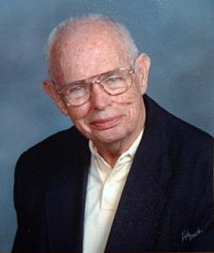
Comments in 2016 from Don Larson to Kent.
HILDY AND I HAVE BEEN BLESSED BY STILL HAVING OUR 4 CHILDREN PLUS 10 GRANDCHILDREN. THE ONLY SAD PART WAS THAT HILDY PASSED ON FEB. 21, 2002, AND ANOTHER GRANDCHILD, AARO, WAS BORN APRIL 1, 2002 IN HELSINKI FINLAND AND ANOTHER ARRIVED JAN 16, 2005, ALSO IN FINLAND----BOTH AFTER HILDYS DEATH. THEIR FATHER BEING OUR YOUNGEST, CURT\.
I WAS BORN IN EVANSTON, IL, IN 1924 WHICH OF COURSE MAKES ME AS OLD AS THE LAND GRANTS. BEING BETWEEN 92 AND DEAD HAS IT ADVANTAGES, PEOPLE ALL THE TIME HELP ME IF THEY SEE ME STUMBLING ALL OVER THE TERRA FIRMA AND EVEN HELP ME UP WHEN I FALL FLAT ON MY TUSH.
I RETIRED IN 1984 SO WE FLEW TO EUROPE TO EXPLORE SWEDEN, DENMARK, NORWAY AND FINLAND FOR A MONTH. GREAT TRIP. HILDY, BEING 6 YEARS YOUNGER THAN I, COULD NOT RETIRE UNTIL 1991. SHE, LIKE YOU, COULD NOT WAIT TO LEAVE SALINA, I SUGGESTED DULUTH AND THE ATOM BOMB EXPLODED. NO WAY SHE SCREAMED, I WANT TO TO ARIZONA--GUESS WHO WON. WELL, MY OLDEST SISTER LIVED HERE AS DID MY MOM AND DAD, SO IT HAD ADVANTAGES BUT I STILL FIND IT HARD TO ENDURE THE SUMMER TEMPERATURES OF 500 DEGREES.
I LOVED ICE SKATING AND ONE SUNDAY WHEN THE SUPER BOWL WAS ON AND IT WAS BORIING I TALKED HILDY INTO GOING WITH ME TO KENWOOD. SHE PROTESTED THAT SHE WAS SHAKEY ON HER SKATES BUT I ASSURED HER THAT SHE'D DO FINE AND I WOULD TAKE CARE OF HER, HAH. NATURALLY SHE FELL AND BROKE HER RIGHT WRIST--MY FAULT OF COURSE. OH, WELL, LIFE GOES ON.
Salina Journal web site, Dec. 4, 2017

EUGENE, Ore. — Donald Curtis Larson, 93, passed away peacefully Nov. 22, 2017, in Eugene, where he moved in March after 26 years in Mesa, Ariz. He was born Nov. 14, 1924, in Evanston, Ill., to Ella (Marshall) and Curtis Larson.
He enlisted in the Air Force in WWII and earned a master’s in teaching through the GI Bill. Don taught math over 30 years in Salina, Kan., mostly at South High, earning a reputation for making math fun while running a tight ship. He read incessantly, enjoyed travel and was active at the Velda Rose Methodist Church.
Don married Hildegard Rose Leopold in 1951, who passed in 2002, and was also predeceased by his sisters, Phyllis Dargatz, Bette Davis, and Dorothy Erskine.
He is survived by: his children, Fritz Larson of Jacksonville, Fla., Polly Rose of Oceanside, Calif., Betsy Ruth of Eugene, and Curt Larson of Pittsburgh, Pa.; and 10 grandchildren.
Surrounded by loved ones in his final days, Don maintained his keen mind and signature sense of humor until his death. The family will hold a memorial for him at their next reunion. Condolences and shared memories are welcome at: 690 W. 24th Place, Eugene, OR 97405.


